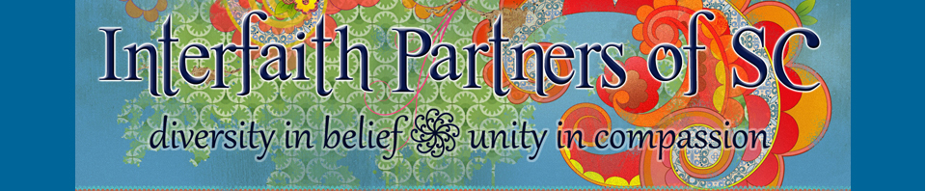

Photography & Video Release (18 and older)

• I give Interfaith Partners of South Carolina (IPSC) permission to use any still and/or moving image, including video footage, photographs and/or frames and/or audio footage depicting my likeness.

• I understand that any creative work which includes my likeness will only be identified with my first name.

• I
nterfaith Partners of South Carolina may use my name in marketing materials: Yes No

• I authorize and consent to allow Interfaith Partners of South Carolina to use images of my likeness (photo or video image) in IPSC-related promotional and program materials, including but not limited to all printed and digital publications.

• I authorize Interfaith Partners of South Carolina to edit, alter, copy, exhibit, publish or distribute these photos/videos for purposes of publicizing IPSC and IPSC’s programs or for any other related lawful purpose.

• I waive the right to inspect or approve the finished product including written or electronic copy, wherein my likeness appears.

• I understand that I will not receive money or other form of compensation for giving Interfaith Partners of SC these rights or for participating in creative work for IPSC.

I have read and reviewed the above, and give my permission for my image to be used in the above manner.

___________________________________________________
Printed Name

___________________________________________________
Signature

___________________________________________________
E-mail

___________________________________________________
Phone

___________________________________________________
Date

