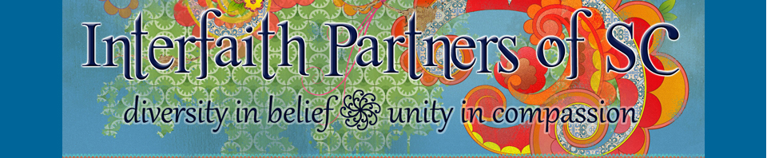

Photography & Video Release (Minor)

I, , hereby certify that I am the parent and/or legal

guardian of , age _.

• I give Interfaith Partners of South Carolina (IPSC) permission to use any still and/or moving image, including video footage, photographs and/or frames and/or audio footage, depicting my/our children named above.

• I understand that any creative work which includes my child will only be identified with my child’s first name and age.
• Interfaith Partners of South Carolina may use my child’s name in marketing materials: Yes No

• I authorize and consent to allow Interfaith Partners of South Carolina to use images of my child (photo or video image) in IPSC-related promotional and program materials, including but not limited to all print and digital publications.

• I authorize Interfaith Partners of South Carolina to edit, alter, copy, exhibit, publish or distribute these photos/videos for purposes of publicizing IPSC and IPSC’s programs or for any other related lawful purpose.

• I waive the right to inspect or approve the finished product, including written or electronic copy, wherein my child’s likeness appears.

• I understand that my child and/or I will not receive money or other form of compensation for giving Interfaith Partners of SC these rights or for participating in creative work for IPSC.

I have read and reviewed the above, and give my permission for my child’s image to be used in the above manner.

___________________________________________________
Parent or Legal Guardian (Printed Name)

___________________________________________________
Parent or Legal Guardian (Signature)

___________________________________________________
Parent or Legal Guardian (E-mail)

___________________________________________________
Parent or Legal Guardian (Phone)

___________________________________________________
Date

